Project Design Phase- II

Technology Stack (Architecture & Stack)

|  |  |
| --- | --- |
| Date | 05 November 2022 |
| Team ID | PNT2022TMID25683 |
| Project Title | Signs With Smart Connectivity for Better Road Safety |
| Maximum Marks | 4 Marks |

Technical Architecture :

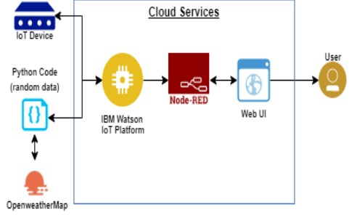

Table 1: Components & Technologies:

|  |  |  |  |
| --- | --- | --- | --- |
| S.No | Component | Description | Technology |
| 1. | User Interface | In what way we have to interact with the application | Python |
| 2. | Application Logic-2 | Logic for a process in the application | IBM Watson STT service |
| 3. | Application Logic-3 | Logic for a process in the application | IBM Watson Assistant |
| 4. | Cloud Database | Cloud which has database service | IBM DB2, IBM Cloudant etc., |
| 5. | External API-1 | Purpose of External API used in the application | IBM Weather API |

Table 2: Application Characteristics:

|  |  |  |  |
| --- | --- | --- | --- |
| S.No | Characteristics | Description | Technology |
| 1. | Security Implementations | Here no one will be able to access without login credentials in a very strong security system | Firebase, Firewall, Cyber resiliency strategy |
| 2. | Scalable Architecture | By increasing the bandwidth the operating range can be increased | IOT Internet |
| 3. | Availability | Available 24/7 | IBM Cloud |
| 4. | Performance | It can support a large amount of users to access the technology | IBM Cloud |